Project Report: Thunderstorm (TH) Forecasting System

1. Project Title
Thunderstorm (TH) Forecasting System using Machine Learning

2. Duration
Approximately 3 hours

3. Introduction
This project focuses on predicting the occurrence of thunderstorms (TH) using machine learning techniques + learning best model tracking with ML FLOW. Atmospheric and meteorological indices are used as input features to train a classification model. The trained model is deployed as a user-friendly web application using Streamlit for real-time predictions.

4. Aim
The aim of this project is to build an accurate and deployable machine learning model that can predict thunderstorm occurrence based on atmospheric parameters.

5. Dataset Used
Dataset Name: Thunderstorm Forecasting Dataset
Format: CSV
Description: The dataset contains atmospheric indices such as SWEAT Index, K Index, Totals Totals Index, and other meteorological features along with a binary target variable indicating thunderstorm occurrence.

6. Tools & Technologies
- Programming Language: Python
- Libraries: Pandas, NumPy, Scikit-learn, Imbalanced-learn (SMOTE), Joblib
- Model: Random Forest Classifier + ML Flow Tracking
- Web Framework: Streamlit
- Deployment: Streamlit Cloud
- Version Control: Git & GitHub
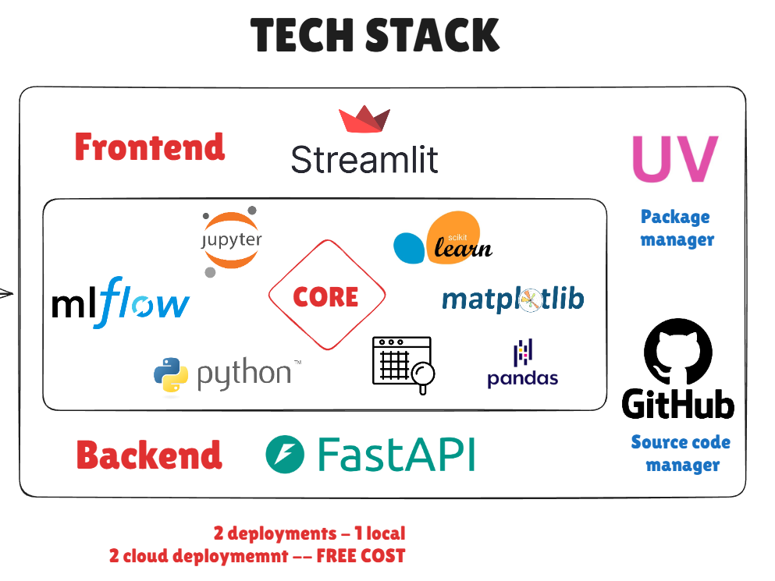

7. Architecture Diagram

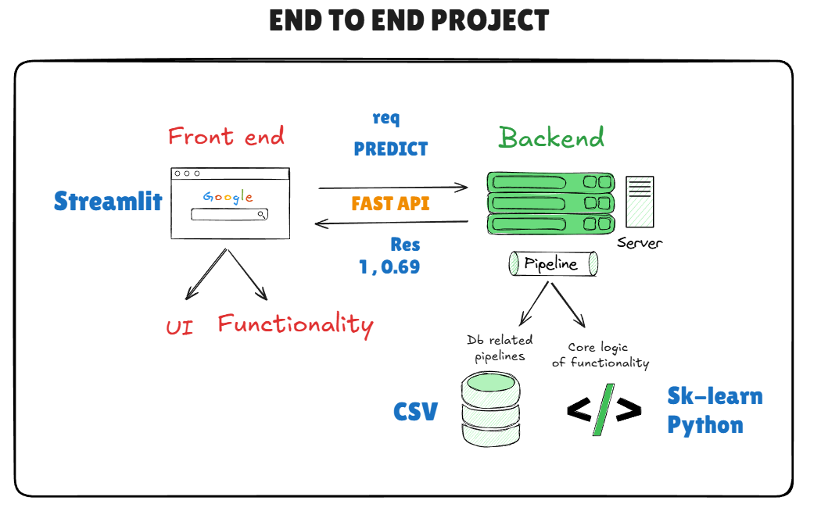

8. Key Steps / Modules
1. Data Collection and Preprocessing
2. Handling Class Imbalance using SMOTE
3. Model Training and Evaluation
4. Model Selection and Hyperparameter Tuning
5. Model Compression using Joblib
6. Model Loading and Prediction Logic
7. Streamlit Web Application Development
8. Cloud Deployment

9. Learning Outcomes
- Understanding of end-to-end machine learning pipelines
- Handling imbalanced datasets using SMOTE
- Model evaluation using multiple performance metrics
- Tracking model results with ML FLOW
- Model compression and efficient loading
- Building and deploying ML web applications using Streamlit
- Basics open source cloud deployment

10. Screenshots

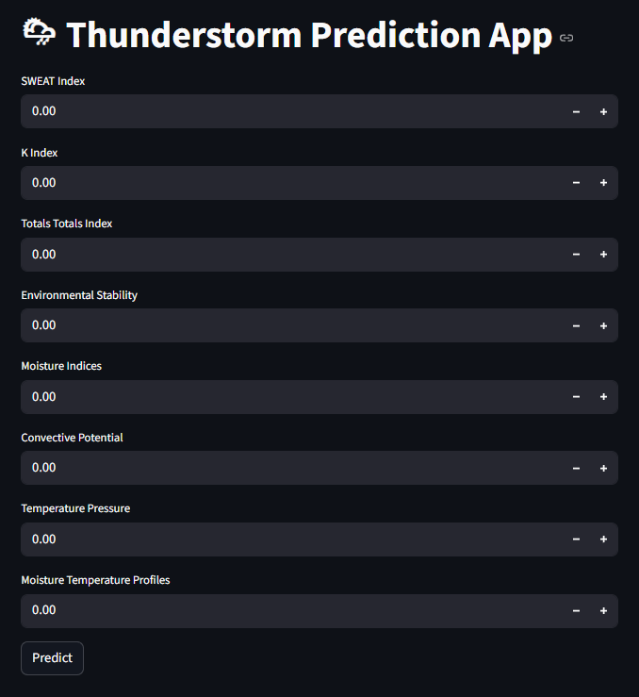

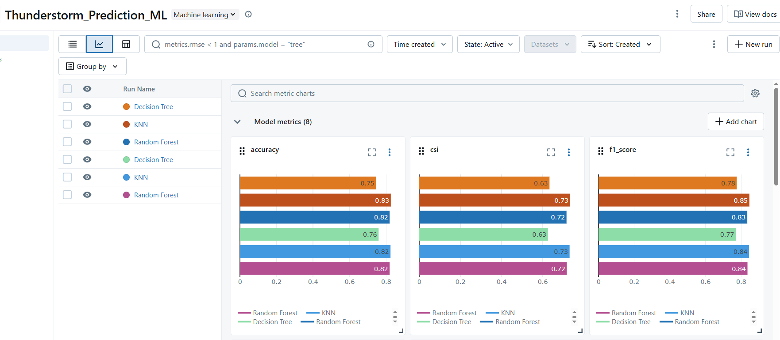

12. Resource Links
- App DEMO : https://thunderstrom-forecast.streamlit.app/
- Youtube thunderstrom video : https://www.youtube.com/watch?v=jfdX1nW-14A
- Github Project Link: https://github.com/d-hackmt/thunderstrom-forecast
- Python : https://www.python.org/
- vs code : https://code.visualstudio.com/
- Anigravity : https://antigravity.google/
- UV : https://docs.astral.sh/uv/
- Git download : https://git-scm.com/
- Github login : https://github.com/login
- Ml FLow : https://mlflow.org/
- Fast api : https://fastapi.tiangolo.com/
- Streamlit cloud : https://streamlit.io/cloud

